### Web Server Exploits

### Subtask 1

Create a reverse shell to the DVWA web app server as we discussed in class. You should submit the following.

1. A screenshot showing that you have access to the DVWA server via a reverse shell.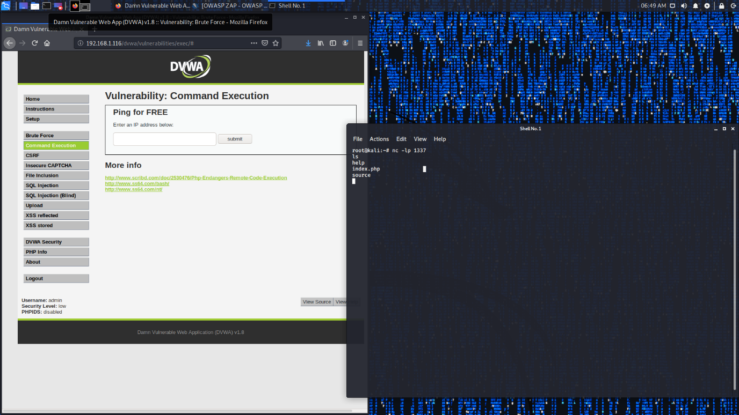
2. A screenshot showing your level of privilege. 